MAE 659 Missile Trajectory Analysis Final Report
Philip Hahn
Digital Fusion Solutions, Inc, Huntsville, AL, 35805
This technical report details the design of a 6DOF modeling both the uncontrolled and controlled trajectories of a modified Hydra 70. The Hydra 70 is controlled using 2 canards which are deployed after motor burnout in an attempt to reduce cross-range. The canards must first despin the Hydra 70, and then assume angular positional authority before attempting to reduce the cross-range. A piecewise linear curve fit of coefficients on the Proportional-Integral controller serves as the method for modifying the control system as a function of input Monte Carlo parameters pitch and yaw rates. [reword last sentence]

Nomenclature
A = amplitude of oscillation
a = cylinder diameter
C_{p} = pressure coefficient
Cx = force coefficient in the x direction
Cy = force coefficient in the y direction
c = chord
dt = time step
Fx = X component of the resultant pressure force acting on the vehicle
Fy = Y component of the resultant pressure force acting on the vehicle
f, g = generic functions
h = height
i = time index during navigation
j = waypoint index
K = trailing-edge (TE) nondimensional angular deflection rate

Introduction
THIS document is a template for Microsoft Word versions 2000-XP or later, or Word for Mac OS X. If you are reading a hardcopy or PDF version of this document, please download the electronic template file, Papers_Template.dot, from the AIAA Meeting Papers Information Page ((“Conferences & Events>Submit/Edit a Paper>Author Kit and Meeting Papers Template” from the AIAA Web site) so you can use it to prepare your manuscript.

Equations of Motion
The equations of motion for a projectile are highly nonlinear differential equations. However they can be broken down into twelve first order differential equations which can be easily solved using an integration technique like a fourth-order Runge-Kutta integrator. Or more simply they can be expressed in vector notation as four equations.

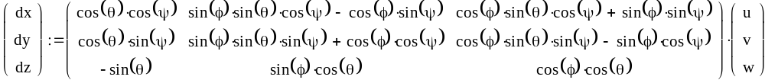 | (1)

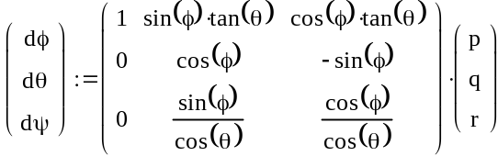 | (2)

(3)
(replace DCM with just the letters Teb)
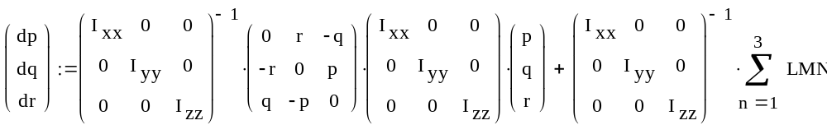 | (4)
These equations fully describe the motion of the projectile through space.

Equation 1 relates the derivative of position to the velocity of the missile. The first derivative of position is velocity – but the velocity is expressed in the body frame, and the position is expressed in the inertial frame, so the Direct Cosine Matrix (T_{eb}) must be used to convert from the body to the inertial frame.

Equation 2 relates the derivative of the angular position to the rotation rates. Similar to equation 1, the derivitive of the angular positions is rotation rate, but the angular position is expressed in the inertial frame and the rotation rates in the body frame. The euler frame is the tensor that transforms the anguar rotation rates from body to the inertial, and like T_{eb} is a function of euler angles.

Equation 3 relates the acceleration of the missile to the body accelerations. There are three. The first is a component due to the rotation rates cross the velocities (reword). There is also the acceleration due to gravity. Since gravity is expressed in the inertial frame, and acceleration in the body frame, we take the transpose of Teb to transform it to the body frame. Finally we have the acceleration forces due to aerodynamics, the rocket motor and the canards.

Equation 4 is the expression for the rotational acceleration. It is a function of the rotation rate, the moment of inertia, and the moment components due to aerodynamics, the rocket motor and canards. (expand)

Initially we must give the projectile position, velocity, orientation and rotation rates by setting the appropriate vectors. Each integration we must update the iframe, transframe, eulerframe and Teb vectors since they are reliant on values being integrated in the simulation. Once the simulation is in motion however the only inputs we have to the system are the aerodynamic forces and moments ( XYZ, LMN) the rocket forces and moments ( XYZ_{R}, LMN_{R}) and the canard forces and moments ( XYZ_{C}, LMN_{C} ). These inputs drive the system.

Let us discuss inputs. Our aerodynamic model is based off of tables that are interpolated by mach number. The missile has canted fins which have limited roll production. The rocket is a single rocket with 2 expansion bells, each located 2.54 centimeters off the centerline of the c.g. They are rotated about x-axis of the rocket in the same sense as to produce a roll, in the same direction as the canted fins. The rocket starts firing almost immediately and continues firing for 1.1 seconds, producing positive thrust and positive roll. The canard model is stowed when the missile initially fires and does not eject until 1.25 seconds, after the rocket motor stops firing. The canard model will be further discussed in the next section.

Control
The control system consists of two canards. The canards are stowed in the vehicle until 1.25 seconds.

Simulation Considerations
One consideration must be made – the guidance must not make updates while in a Runge-Kutta integration. This is an artifact of digital simulation. Since our guidance routine is called from inside the same update() routine that contains our four core differential equations – and thus will be called four times per integration – we must provide a method that only updates our control at the beginning of the integration cycle. This is accomplished by having a Boolean value that is set to false by the integrator after the first update() call, and true after the last update() call. The guidance routine will then check this Boolean value and if it false, it will not change its output parameters (XYZc, LMNc) but hold them at the value it was last set at.

Guidance Methodology
The controllers for the canards are Proportional-Integral controllers in three stages. The first stage exercises roll control. Once roll control is established, then the next controller tracks to an angular position. After obtaining the angular position we desire the divert control system attempts to reduce the cross range.

(flow chart)

The controllers implemented in this model have hard coded start times. The roll control starts at 1.25 seconds, the angular control starts at 2.2 seconds, and the divert control starts at 3.3 seconds. Another method would be to have the control system monitor each variable – have the angular control watch the roll rate, and the divert control watch the angular position – and have each subsystem start themselves once a certain tolerance was obtained. This method, though more clever, was not used to keep consistency across runs.

The roll and angular controllers had constant coefficients on the proportional and integral terms of the divert equation. The divert controller had a variable integral coefficient, depending on the initial yaw rate. This was determined by doing a series of runs, varying the yaw rate by 0.025 rad/s over the domain we were asked to perform in. I then fit 2 lines to the data and interpolated those lines to derive a coefficient as a function of initial pitch rate. I felt this was acceptable since a flight computer capable of measuring in-flight rates should be able to measure the initial rate.

Sizing
The initial C_{L} and C_{D} were 1.5 and 0.002, respectively. The lifting surface force is a function of dynamic pressure, surface area, lift coefficient and the angle of attack. The latter three parameters are the ones that we can readily vary. I raised the surface area by a few thousandths of a meter, squared, and iterated a few times (Each time requiring some minor tweaks on the coefficients of the control system) before realizing that some more gains could be made in the area of attack. After a few more iterations I settled on a maximum angle of attack of 9.96 degrees and a surface area of 0.003 m2. One could argue that the angle of attack is getting excessive. This is only half of the equation however because we now need to back out the correct C_{L} and C_{D} for the canard.

The first step is to determine geometry. There are many ways we could choose to configure our airfoil. I chose to make square canards with the span equal to the radius of the fuselage. Each canard is 0.0353m wide and 0.085m long. The other option would be to flip it and have a shorter chord and longer span. This would seem like a no-brainer, as your lift coefficient would be much higher (three times, in fact) however that is a bigger moment that we must be able to support on our hinge on the airframe, and it turns out our stubby canard works fine.

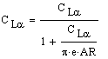 | (5)

Table 5 shows the equation to transform the lift curve slope from a 2D infinite airfoil case into a real, 3D airfoil case for a flat plate. Sine I am assuming my canard to be a flat, square, uncambered member this equation will work. The variable e is the Oswald efficiency factor and was derived from a table in Anderson. The aspect ratio needs some consideration. We are not actually modeling a wing, we are modeling half of a wing – one side of our canard will experience wing tip vortices like the edge of a wing, the other side will feel the middle effects of a wing midsection much like any common jet. So in order to get a proper result out of this equation we must double the width of our canard before calculating the aspect ratio, which is the width, squared, over the area. This doubles the aspect ratio which raises our lift curve slope slightly. This result makes sense: wing tip vortices are a loss, and on a normal wing are experienced on both sides of a wing, but on our canard we should only be experiencing it on one side as the other side is butted up against the airframe. So our lift curve slope should be higher.

Our resulting C_{Lα} is 1.83. The drag then is C_{D0} + kC_{L}². k is the inverse of π times the efficiency factor times the aspect ratio, and C_{D0} for a flat plate is approximately 0.02. The coefficient k is thus a constant throughout the simulation, and C_{L} is calculated on the fly as a function of alpha. Once α is calculated we can calculate drag, and then calculate our lift and drag forces

In order to calculate alpha we need to transform the velocity from the body axes into the canard axes. Then we find the angle of attack relative to the canards, subtracting off any deflection from our control system. We can then calculate our local velocity, Mach number, dynamic pressure, C_{L} and C_{D}. Equation 5 shows the final resulting forces for a single canard. Summing all forces results in the total forces for the canard system, and crossing each individual canard’s location on the airframe relative to the c.g. by the canard’s force vector results in the moment vector.

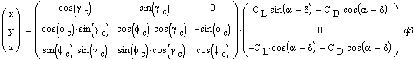 | (5)

Results
Figures 1-6 (check,link) compare the baseline simulation to the controlled simulation. The results closely match the undisturbed numbers outlined in the project statement. The control system starts at the prescribed time at reduces the roll rate to nearly 0, and then reduces the crossrange to 0 by the end of simulation. There is a slight altitude gain in the controlled missile.

Figure 7 (check … mc plot) shows the controlled results, consisting of 25 Monte Carlo runs, p and q had a normal distribution of 0.15 rad/s and zero mean. The canard controller does an excellent job of reducing the cross-range error. The majority of the 25 Monte Carlo runs lie within 1.5 meters of cross range error, and the most extreme cases fall within 4 meters. Left to their own devices these missiles in the extreme cases would have been off by up to 250m, similar to the z-coordinate direction on the graph.

Conclusion
The two-piece linear curve fit is an acceptable method that gives good results, reducing the cross range error significantly. Two additional canards could be employed orthogonal to the existing canards to reduce vertical error. This would also have the advantage of reducing the requirements on the canards during despin and angle acquisition.

Appendix
An appendix, if needed, should appear before the acknowledgements.

Acknowledgments
The preferred spelling of the word “acknowledgment” in American English is without the “e” after the “g.” Avoid expressions such as “One of us (S.B.A.) would like to thank…” Instead, write “F. A. Author thanks…” Sponsor and financial support acknowledgments are also to be listed in the “acknowledgments” section.

References

Engineer, Engineering Development, Redstone Arsenal, Member.
These were the numbers provided on your slides for the canard system.
Reference for Anderson’s Aero Text

